Human Heart Worksheet
From the list of label options provided in the text box below, use the diagram reference numbers to complete the parts of the heart table. The correct answer is printed on the back of this sheet. Don’t check the answers until you have completed the activity.

Label options

Inferior Vena Cave (Venea cava Inferior); Aorta; Pulmonary vein; Left atrium (Atrium sinistrum) Pulmonary valve; Left ventricle; Superior Vena Cave (Venea cava Superior); Mitral valve;
Aortic valve; Pulmonary artery; Right ventricle; Tricuspid valve; Right atrium (Atrium dextra)

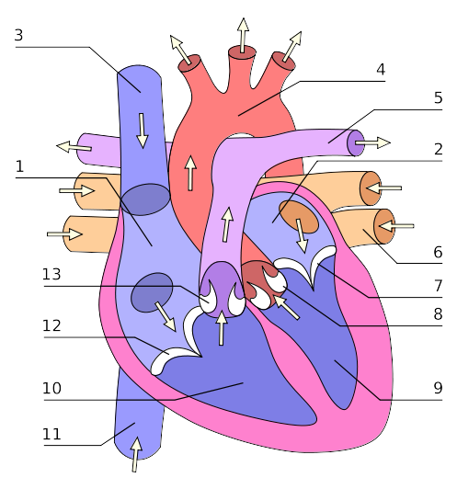

Parts of the heart table
1. |  | 8.
2. |  | 9.
3. |  | 10.
4. |  | 11.
5. |  | 12.
6. |  | 13.
7.

Solution

Check the diagram below to see if your numbers correspond with the correct label in the original diagram above.

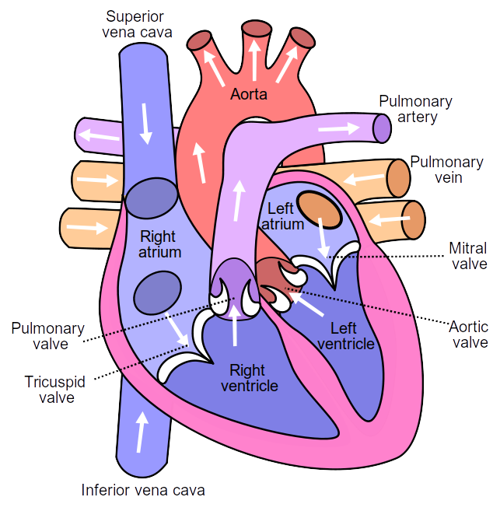

Attributions
Heart with numbers by Wapcplet, published under Creative Commons Attribution-Share Alike 3.0 Unported license.
Heart with labels, by Wapcaplet &Yaddah published under Creative Commons Attribution-Share Alike 3.0 Unported license.

2021 © Commonwealth of Learning Creative Commons Attribution-Share Alike 4.0 International

